**#Day 1**

* **Python Programming Basic Questions ( 3 Basic questions everyday from Leetcode, HackerRank and GeeksforGeeks)**

1. **HackerRank**

**SWAPCASE:**

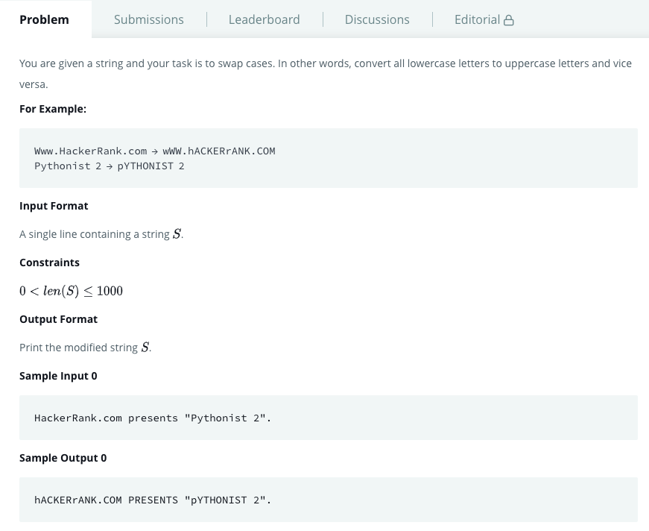

**Solution SwapCase:**

**def** swap_case(s):

**return s.swapcase() # swapcase function converts upper to lower and vice versa**

**if** __name__ == '__main__':

s = **input**()

result = swap_case(s)

**print**(result)

**Problem 2: Leetcode**

**Reverse Integer**

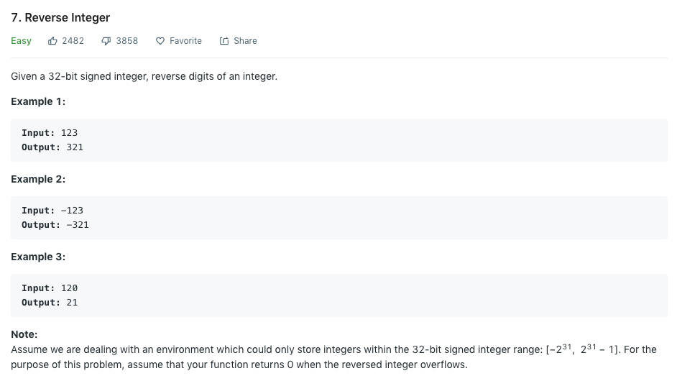

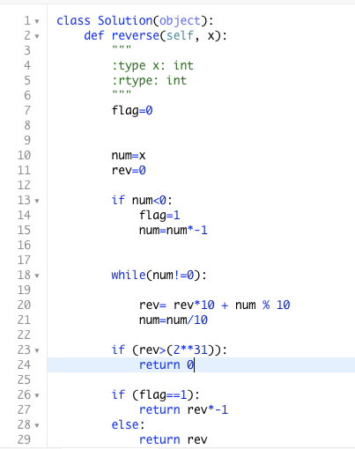

**GeeksForGeeks:**

**Python program to add two numbers:**

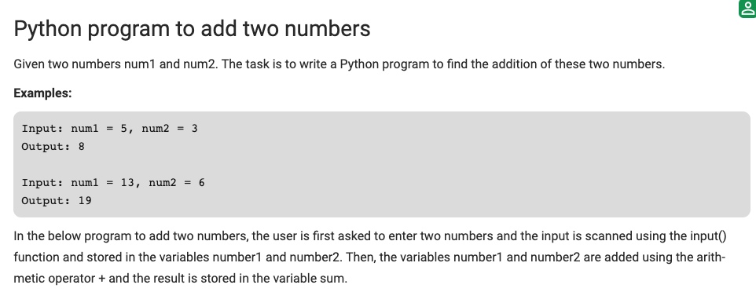

**Class Sum:**

**def sum(self, a,b):**

**s=float(a) + float (b)**

**return s**

**def main():**

**a=input(“First Number : “ )**

**b=input(“Second Number : “)**

**x= sum(a,b)**

**print(“Sum of {} and {} is {}”, a, b, x)**

**SQL :**

